|  |
| --- |
|  |
| **Project Title**  **Test Plan**  **Cohort: A**  **Group: 1**  **Group members:**  **ABC 123 (Team leader)**  **XYZ 456** |
|  |

|  |
| --- |
|  |

Document Acceptance and Release Notice

This document is authorised for release once all signatures have been obtained.

|  |  |  |  |  |  |  |  |
| --- | --- | --- | --- | --- | --- | --- | --- |
| PREPARED: |  | Date: |  | / |  | / |  |
| (for acceptance) | <Name>  Project Manager, Student Group |  |  | | | | |
|  |  |  |  | | | | |
| ACCEPTED: |  | Date: |  | / |  | / |  |
| (for release) | Project Sponsor, VIT |  |  | | | | |

**Table of Contents**

1. Introduction 1

1.2 Scope 1

1.3 Quality Objective 1

1.4 Roles and Responsibilities 1

2 Test Methodology 1

2.1 Overview 1

2.2 Test Levels 1

2.3 Test Completeness 2

3 Test Deliverables 2

3.1 Overview 2

3.2 Test Cases 2

4 Resources and Environment Needs 2

4.1 Testing Tools 2

4.2 Test Cases 2

5 References 3

**List of Figures**

Fig 1. 1 My lecturer. 1

Fig 3. 1 Testing strategy diagram. 2

**List of Tables**

Table 3. 1 Test Case table. 2

**Glossary**

|  |  |
| --- | --- |
| **API** | Application Program Interface |
| **AUT** | Application Under Test |
|  |  |

# Introduction

*Brief introduction of the test strategies, process, workflow and methodologies used for the project*

## Scope

Scope defines the features, functional or non-functional requirements of the software that will be tested. Also mention functional or non-functional requirements of the software that will NOT be tested

## Quality Objective

Here make a mention of the overall objective that you plan to achieve with your testing

Some objectives of your testing project could be

* Ensure the Application Under Test conforms to functional and non-functional requirements
* Ensure the AUT meets the quality specifications defined by the client
* Bugs/issues are identified and fixed before go lived

## Roles and Responsibilities

Detail description of the Roles and responsibilities of different team members like QA Analyst, Test Manager, Configuration Manager, Developers, Amongst others

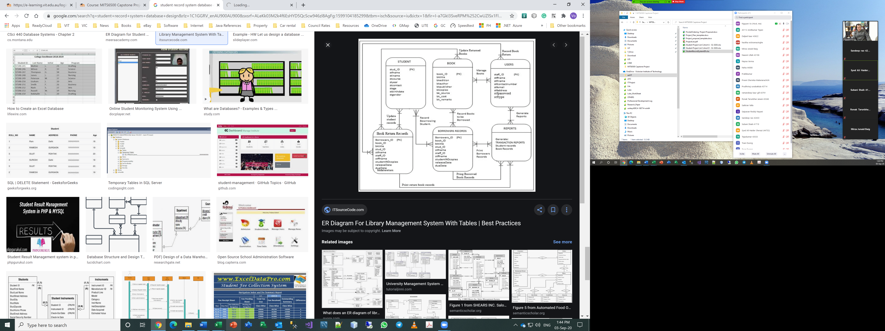

Fig 1. My lecturer.

# Test Methodology

## Overview

Mention the reason of adopting a particular test methodology for the project. The test methodology selected for the project could be Waterfall, Iterative, Agile, Extreme Programming

## Test Levels

Test Levels define the Types of Testing to be executed on the Application Under Test (AUT). The Testing Levels primarily depends on the scope of the project, time and budget constraints.

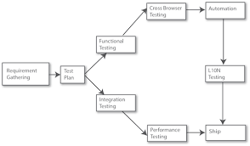

Fig 3. 1 Testing strategy diagram.

## Test Completeness

Here you define the criteria’s that will deem your testing complete. For instance, a few criteria to check Test Completeness would be

* 100% test coverage
* All Manual & Automated Test cases executed
* All open bugs are fixed or will be fixed in next release

# Test Deliverables

## Overview

Here mention all the Test Artifacts that will be delivered during different phases of the testing lifecycle. For example, Test plan, bug report, test strategy, requirement traceability matrix

## Test Cases

Here you need to write the few test case you have designed for testing

Table ‑ Test Case Table

|  |  |  |  |  |  |
| --- | --- | --- | --- | --- | --- |
| **Test Case Num** | **Description** | **Inputs** | **Expected Output** | **Actual Output** | **Test Result** |
| 101 | Multiplication module………. | A=2, b=5 | 9 | 10 | Fail |
|  |  |  |  |  |  |
|  |  |  |  |  |  |
|  |  |  |  |  |  |

# Resources and Environment Needs

## Testing Tools

Here mention all the tools you need to perform the testing. For example Requirements tracking tool, bug tracking tool or automation tools.

## Test Cases

Here mention the minimum hardware/software requirements that will be required to test the Application.

# References

[1] IEEE format for reference